|  |  |  |  |  |
| --- | --- | --- | --- | --- |
| |  |  | | --- | --- | | Friend Of Earth Ireland |  | |  |  | |
| Rebuild Design Document  Friends of the Earth  In Ireland, Friends of the Earth was launched in October 2004. We promote education and action for environmental sustainability and environmental justice. We focus on Ireland's response to the big environmental challenges of our time such as climate change and energy, the waste crisis and the spread of GM crops and food. To get start right away, please visit the original website first.  <https://www.foe.ie/> |

# Needs Analysis-Personas

Personas are fictional characters, which you create based upon your research in order to represent the different user types that might use the site. Creating personas will help you to understand your users' needs, experiences, behaviours and goals.

Creating personas can help you step out of yourself. It can help you to recognize that different people have different needs and expectations, and it can also help you to identify with the user you’re designing for.

Resources:

<https://www.interaction-design.org/literature/article/personas-why-and-how-you-should-use-them>

<https://unsplash.com/search/photos/persona>

<https://www.userpersonaimages.com>

Rebuild the website

Analysis – sister group website

Please visit:

<https://foe.scot/>

<https://www.foei.org/>

Colour Scheme

Friends of the Earth is the network of environmental groups, the original website of FOE Ireland is lack of connection between its sister group website and itself in terms of a mutual colour scheme. This results in inconsistency as the entirety, especially for the users on their first visit to website.

The colour act as a key function that grabs the attention of the user. Colour is the easiest aspect to remember when come to encountering new things for the users. In our rebuild project, a bright background is chosen for contrast, text, and readability reasons as adults would be our main user, also to keep the similarity with sister group website.

Our users may read a lot of text and if relevant watch an occasional video. But most of them will seek information through texts. By having a light UI could makes it easy for users to read a lot of text without straining their eyes.

For color physiology we are going for green colour as fundamental base for obvious reasons, humans find green is a colour that is connected to the environment, trees and plants. Since green is so natural to our eyes it grabs attention when properly used.

There are good reasons for choosing a bright background. Contrast, text, and readability and the ability to work with a wide range of subtle colours are some of them.

Resources:

<https://uxplanet.org/how-color-can-effect-emotion-ccab0431b1d>

<https://www.toptal.com/designers/ui/dark-ui>

<https://medium.com/@CanvasFlip/dark-ui-vs-light-ui-how-to-make-the-right-choice-5ddde9baabdb>

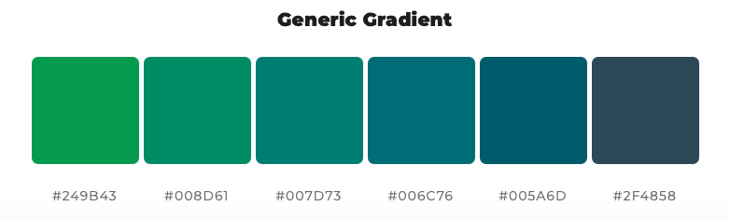

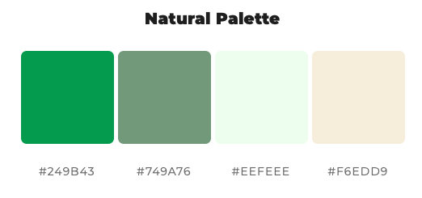

Google fonts : Raleway & Open Sans

Raleway is an elegant sans-serif typeface family intended for headings and other large size usage.

Open Sans was designed with an upright stress, open forms and a neutral, yet friendly appearance. It was optimized for print, web, and mobile interfaces, and has excellent legibility characteristics in its letterforms.

It is all about readability

Colour Gradient

In our design, we decided to use generic gradient for header and footer section. We prefer a dark theme that gives the website an exciting and stylish appearance for younger generation. Also it take a smooth balance between the main text section and from end to end for reading comfortability.

Natural Palette

And the main contents would be applied by natural palette as bright background works well for news or blog websites, who get most of their traffic in day time.

Resources: <https://mycolor.space/>

Layout

In addition, the layout of FOE Ireland is out of date, compared to the others, it needs a modern layout template to reach more users, most importantly make them come back to our website regularly.

What header should have?

* **logo & Motto**

FOE Ireland does not have its own distinct logo, therefore a motto is essential to the header particularly for this website since there are four sister websites, users could easily get confusions without informing them at the entry of website. Moreover, a motto would give visitors a strong impression of the website.

* **Search bar** (*This function is left for further development )

On content-heavy websites, the search box is often the most frequently used design element. When users are looking for a specific topic, they will immediately look for a search box to get to their final destination quickly and painlessly.

* **Donate**

Donate button on a non-profits website is big deal. Supporters expect to see it when they arrive on your website. If donors have a tough time finding the button they may change their minds or give up.

* **Navigation**

Creating a responsive navigation header is our first improvement on this website, These sections of the webpage will include links to the most important sections of the site.

* **Social media & contact us**

Social media is an extremely valuable tool for promoting marketing content. We have decided to create a mini navigation with icons containing the link of contact and social media in the header.

Home page is the first impression

* Instead of giving too much text or information to users in the home page, we are using slideshow component for cycling through images.
* Keeping the home page as simple as possible but also making it as clear as users would find what they need and where to go. A section with three columns is created as an extension and introduction of links: Blogs, News, About us.
* Too much contents in home page would result in a long scroll down in mobile environment. We intend to avoid this.

Footer is like when finishing a book

* Recursive Design

User can find donate button at the header and footer to increase our conversion rate of per donate to visiting flow. So are the social media and contact information with details.

* To differentiate FOE Ireland and the other sister websites, as well marketing purpose, there is a section to direct users to FOE international etc..

About Us Page

* Too much information about FOE Ireland is given to users from original website, hence a section of video linked from Facebook is created to let our users have a quick and simple idea about the website.
* Use bootstrap 4 collapse to hide and show large amount of contents. As a result, not only it reduce the scroll down length but also user could focus on what their interests.

Organization and make each article stand out is the key

* Using jumbotron for each article with image, heading for calling attention to information.
* Each article has border and a proper margin.
* Each row can only contain three columns for layout simplicity.
* In the bottom, designing pagination to each page If a web site has lots of pages.
* We have created a file called singlepost.php that allows article contents fetched from database when users click on the heading of each article in blog page.
* In news page, using collapse function to hide a large of amount of paragraph. Reader can click button to expend it.

Make donation with ease

* Remove the background image to make our donation page as clear as possible for letting users focus on the form input.
* Divide donation section into two, one is for a simple greeting and prompting the confirmation when donation is completed successfully, the other is a simple form for user input.

Rebuild the website

Analysis – competitor website

Please visit:

<https://voiceireland.org/>

<https://amazonwatch.org/>

Rebuild the website

Wireframe - Header

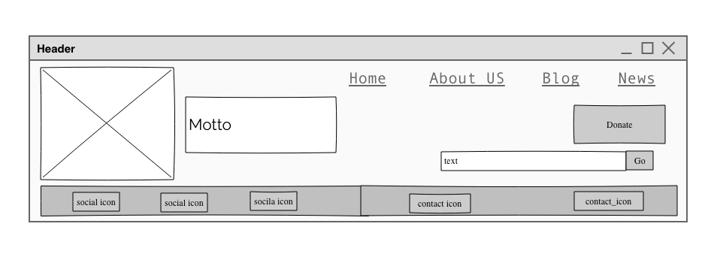

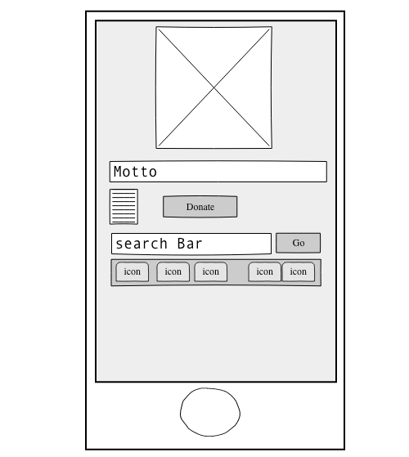

Rebuild the website

Wireframe - Footer

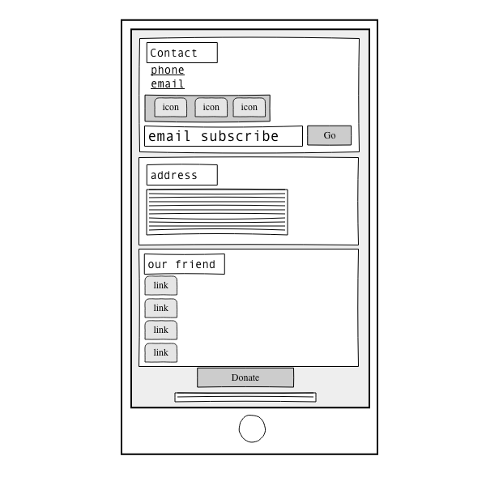

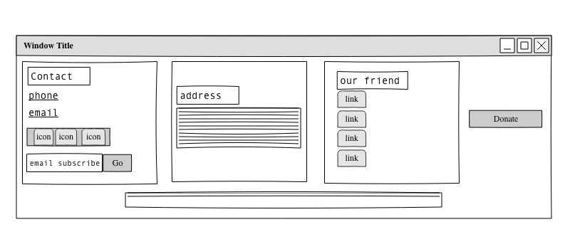

Rebuild the website

Wireframe – About Us

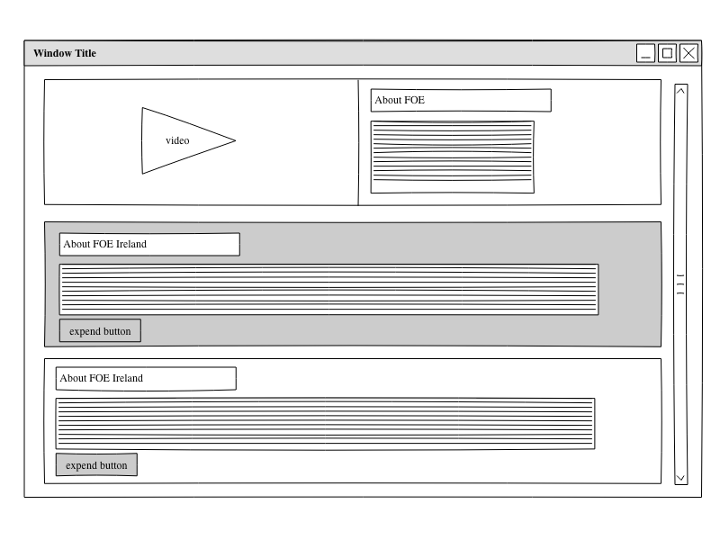

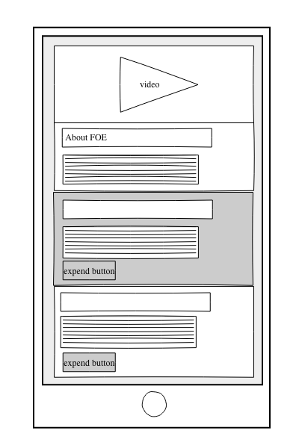

Rebuild the website

Wireframe – Articles

## 

Rebuild the website

Wireframe – Donate

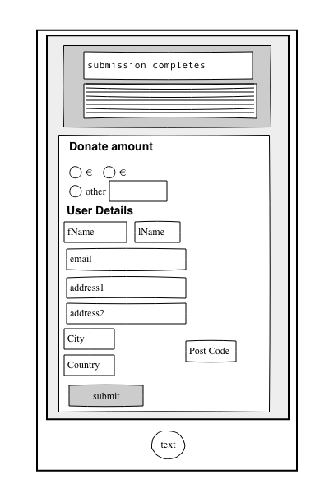

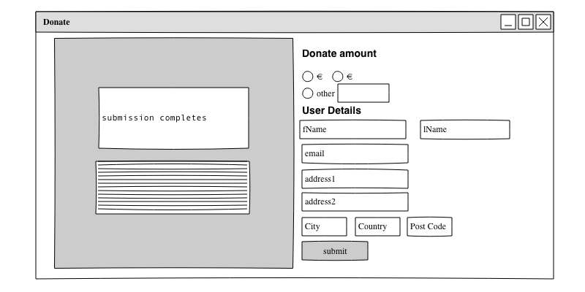

The main purpose of a content audit is to produce a listing of the site’s content, usually in a big spreadsheet.

Content Audit

|  |  |  |  |  |
| --- | --- | --- | --- | --- |
| ID | Navigation | Page title | URL | Comments |
| 0 | Home | FOE_IE_Home | <http://localhost:8888/foe_Jimmy/WebsiteCode/index.php> |  |
| 1 | About us | FOE_IE_About | <http://localhost:8888/foe_Jimmy/WebsiteCode/about.php> |  |
| 2 | Blog | FOE_IE_Blog | <http://localhost:8888/foe_Jimmy/WebsiteCode/blog.php> | Show article of blog |
| 2.1 | The Young FoE Europe Summer Camp | FOE_IE_Post | <http://localhost:8888/foe_Jimmy/WebsiteCode/singlepost.php?page=blog&id=7> |  |
| 2.2 | Hiring: Young FoE Ireland Food Sovereignty Events & Communications Officer! | FOE_IE_Post | <http://localhost:8888/foe_Jimmy/WebsiteCode/singlepost.php?page=blog&id=6> |  |
| 2.3 | We're not going down without a fight | FOE_IE_Post | <http://localhost:8888/foe_Jimmy/WebsiteCode/singlepost.php?page=blog&id=5> |  |
| 2.4 | Apply now to take part in Mobilize. Resist. Transform. Environmental Issues Course 2018! | FOE_IE_Post | <http://localhost:8888/foe_Jimmy/WebsiteCode/singlepost.php?page=blog&id=4> |  |
| 2.5 | We are scared. We are angry. It's time to rise. | FOE_IE_Post | <http://localhost:8888/foe_Jimmy/WebsiteCode/singlepost.php?page=blog&id=3> |  |
| 2.6 | We can spark the solar revolution if we act right now. | FOE_IE_Post | <http://localhost:8888/foe_Jimmy/WebsiteCode/singlepost.php?page=blog&id=2> |  |
| 2.7 | Friends of the Earth Keep Cup - Reduced Rate This Week! | FOE_IE_Post | <http://localhost:8888/foe_Jimmy/WebsiteCode/singlepost.php?page=blog&id=1> |  |
| 3 | News | FOE_IE_News | <http://localhost:8888/foe_Jimmy/WebsiteCode/news.php> | Shows list of news posts |
| 3.1 | News Pagination |  |  | For further develop |
| 4 | Donate | FOE_IE_Donate | <http://localhost:8888/foe_Jimmy/WebsiteCode/donate.php> |  |
| 5 | Take Action | Take action |  | For further develop |

Rebuild FOE Ireland

Sitemap

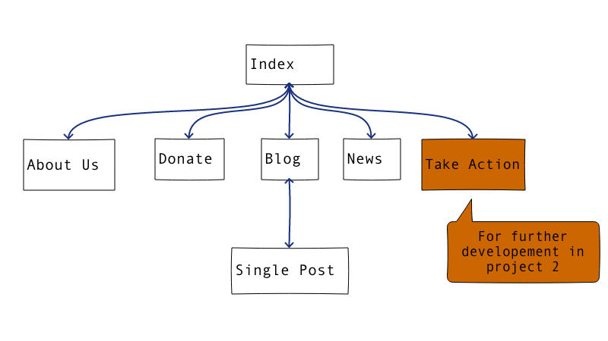

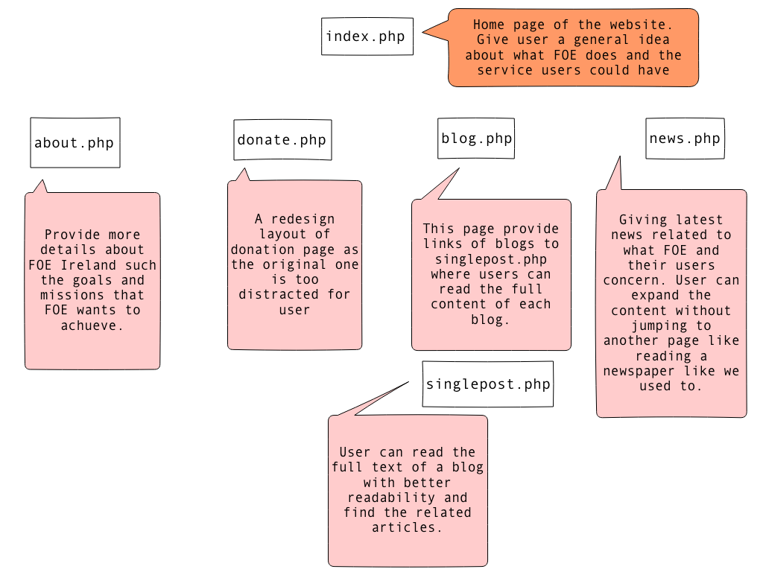

Rebuild FOE Ireland

Summary of the website

The end

Thank You